Compliance Checklist

As a prospective Policyholder, you have the right to the following information:
A. Intermediary status (indicate with an x in the yes / no box) Yes I No
Has the intermediary explained the purpose of their visit?
- Has the intermediary disclosed the following information to you by means of a disclosure letter:
  - The intermediary's full name, title and designation?
  - Office details (physical and postal address) of the intermediary?
  - Telephonic and electronic contact details of the intermediary?
- Are ou returnin the status disclosure letter si ned?
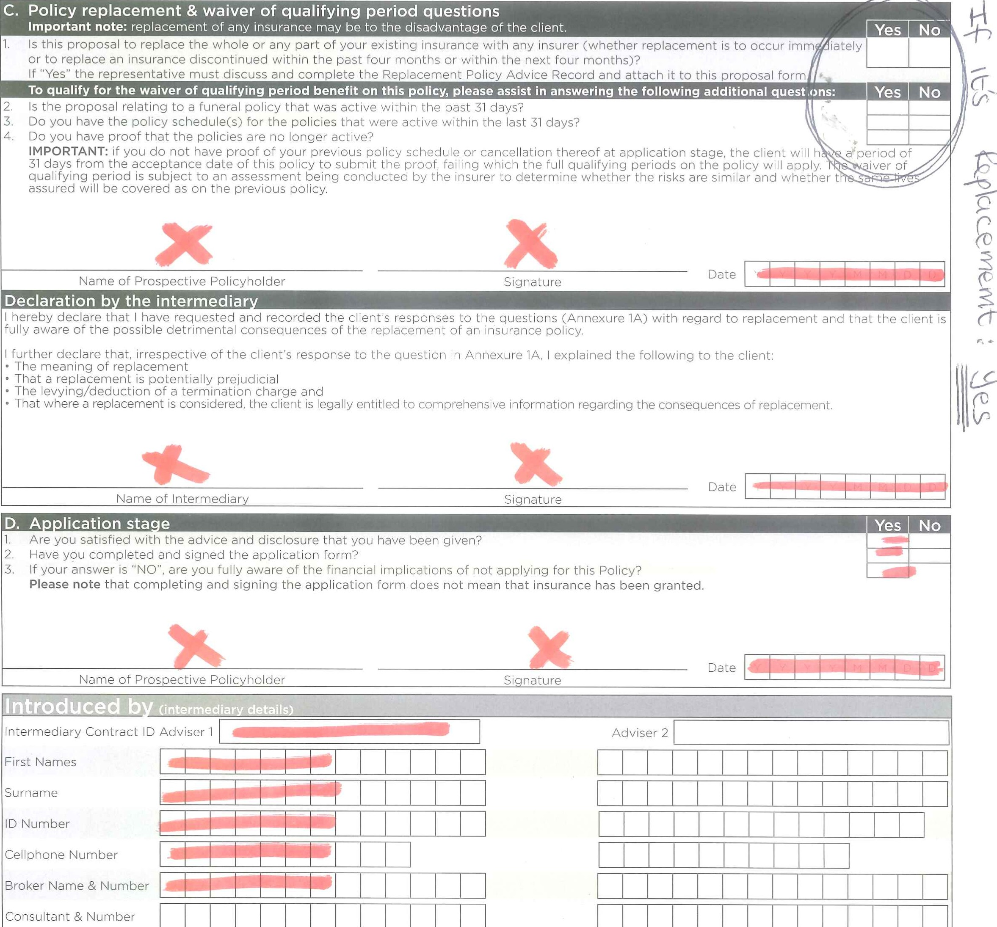
B. Advice Yes I No
The
full
re
istered
name
and
address
of
insurer?
h.
The
claims
notification
procedure?
Has the intermediary taken your circumstances into account in order to satisfy your financial needs?
- Have you accepted the recommendation leading from this financial needs analysis?
- If your answer is "NO", please state the reason,
2. Has the intermediary disclosed the following information to you:
Please note: this information is all contained in the cover pages of this policy application which the intermediary should leave with you. The name and type of policy?
- The premium?
- The type, extent and limitations of the benefits?
- The qualifying period?
- Who in your family can be covered as a spouse, as parents, as children and as wider family members? (if relevant) The commission and remuneration payable to the intermediary?
g. The 60-day cooling period?
Product Version: November 2021 SP7942396

Application for a Sanlam
Policyholder
- First names
- Surname
Previous name Also known as (alias)
ID number —IZIZæa
Issuing country of identity number
Country of residence ntry Of b i rth
Ethnicity
- Telephone numbers (Include dialiing code)
Home phone We will send information regarding your policy to your
Work phone Email cell phone.
Postal address Physical address same as postal address
Building/Complex/Unit
Suburb Postal Code
City Province
Physical address
Building/Complex/Unit Street/Box/Bag
Suburb Postal Code
City Province
Update all other active policies with the telephone numbers and postal address above. Y N Would you like to receive all documents email? Y N
Employment details
Employer Employment date
Unit/Division
Union Deductions
Occupation Source of income
Education level Payment frequency Mor L '-fly Weekly Salary pay day
Employee number Date of last income
Sanlam Sky paypoint number Employer/Switchboard number
Payment details (The Policyholder must be the person paying the premiums.)
- Payment method Stop Orcler Debicheck Debit Order * Monthly Premium R
Bank details
- Name of bank * Account number
- Branch name Branch code
Account type Curt-pet Savings Transmission * With effect from
- Preferred debit order selected payment day (Usually your salary pay day). Your bank statement will show SanIamSky.
Payment Details Authority
I allow Sanlam Developing Markets Limited (Sanlam) to adjust the date that I agree that in order to cancel the debit order instruction I would they take the money from my bank account to be the date that I need to cancel with Sanlam directly. get my salary or to a date that Sanlam needs it to be for operational Y N reasons within its business.
I agree that I am responsible to ensure that my premiums are paid. I agree that a debit against my bank account may be done by using In the event that my employer is unable to deduct the premium the EDO (Early Debit Order), used by the banks, which allows for that Sanlam is allowed to take the money tracking of credits to my bank account. from my salary, bank account I agree as supplied by me. from my
I confirm that the above deduction details that I have supplied are correct. Stop order 1st salary deduction date Y Y Y Y
Stop order deduction and pay-over authority (applicable to Stop Order only with a new instruction, in writing. This instruction is in force for any I instructed my employer to take the monthly premium from my salary and to pay premium increase advised by Sanlam. I understand that for purposes of it to Sanlam Developing Markets Limited (Sanlam) where I have an insurance policy. ensuring the payment of my premiums via stop order Sanlam has to share information with my employer By signing this payment details authority I
I will allow this, until I cancel this instruction in writing, or until I change it give Sanlam permission to share my information with my employeL
The banking details provided on this application form will be used to pay any refunds and cash back benefits that might be due on the policy, unless SDM is advised otherwise by the Policyholder.
The policyholder must be the person paying the premiums.

Application for a Sanlam

Principal life assured
Does the policyholder require cover?
Spouse First names Surname
Children First names Surname
Parents First names Surname
Wider family First names Surname
Beneficiaries First names Surname Contact Details Gender Age Title
(Note. This is who will get the money from the claim if the principal life assured dies.
The appointment of a beneficiary younger than 18 years old may slow down the payment of a claim.)
Legal limits on Child death claim payments
Therebre laws about how much we can pay for death claim payments for any life cmcler the age of 14 across policies.
We will apply these limits. These limits are:
- We can pay out to a maximum of R20 000 before a child's 6th birthday; and
- We can pay out to a maximum of R50 000 when a child is between their 6th and 14th birthday.
Limits on payment of cover amounts
- In addition to the limits imposed in the policy, there are laws about how much we can pay as a cover amount in respect of a life assured. We may never exceed this amount for you in terms of this policy.
In terms of the policy, the following cover limits will apply: The maxinnurn cover amount that any one life assured will have is as follows:
- RIOO 000 for the principal life assured and spouse covered in terms of the spouse category.
- R50 000 for a parent and wider family members.

Application for a Sanlam

Plan Premium
Value Funeral Plan
ID number Cell / phone number Plan Gender Premium
ID number
(It is preferable for a client to provide the full ID number of their children) Age Plan Gender Premium
ID number Plan Gender Premium
ID number Relationship Age Plan Gender Premium
Total Monthly Premium (Minimum Funeral Premium R80)
ID number Relationship Cell / phone number Percent
* Escalatio Premium 10% & Cover 8% Issue date

Premium 5% & Cover 4% or

Declaration
I understand that this application boo e O ICY,

I understand that:
- I must complete all the information requested on this application form and the
Compliance Checklist form;
- Sanlam relies on the information included in this application form and any supporting documents to assess their risk in terms of the policy;
- Sanlam considers the following information material to such assessment: age of the lives assured, my relationship to the lives assured and the confirmation of the existence of a previous policy.
- In the event of a conflict between the application form, the policy schedule and this policy document (or any disclosures made to you), the terms and conditions of the policy document will prevail to the extent of such conflict.
I declare that:
- I have not signed this application form without completing all the fields;
- All information provided by me, as completed in this form, is true and correct. • I accept that I am limiting my right to privacy to allow the assessment of the risks and of any claim benefits, under any policy issued because of this application. allow:
- Sanlam to get from any person including but not limited to a medical
which Sanlam deems as necessary, and to share with other Insurers that information and any information in this application or in any related policy or other document.
Any such information that has been received and given, and as between Insurers has to be shared either directly or through a database operated by or for Insurers as a Group, at any time (even after my death) and in such detailed abbreviated or coded form from time to time decided by Sanlam or by the Operator of such database.
- I agree that Sanlam may to the extent allowed by Law use or distribute for use within the Sanlam Group and to parties with whom it has business relationships, my personal information so as to identify my financial needs and to provide me with financial and related services to meet these needs.
- I give my consent to Sanlam to use my personal information to take any action necessary to trace me and my beneficiaries for the purpose of any unclaimed benefits and to make such information available to Sanlam's tracing agents. º I have read and understand the section on Protection of Personal Information and where applicable, consent to the processing of my personal information for purposes set out therein.
I acknowledge that I have read and understood these declarations.
For office use only

